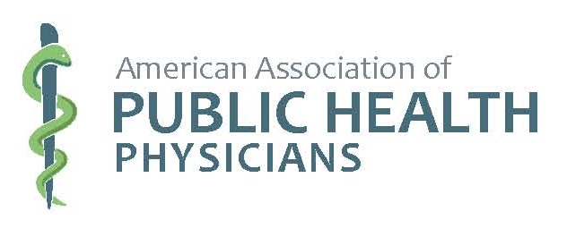

Preventive Services Toolkit (PSTK) Seminar

AAPHP Public Health Physician Summit

Atlanta, GA, November 4 and 5, 2017

Presented by

Joel L. Nitzkin, MD

Handout Table of Contents

Schedule, Goal and Teaching Objectives
Advocacy Strategy Worksheet
Seminar Evaluation Form
Saturday, November 4, 2017 Slide Sets (pages numbered lower right)
Module 1: Introduction and Overview
Module 2: Mindsets and Framing
Module 3: Epidemiology as a Policy Tool
Module 4: Stakeholder Concepts
Module 5: Stakeholder Analysis – practical application
Sunday, November 5, 2017 Slide Sets (pages numbered lower right)
Module 1a: Introduction to 2d Half Day
Module 6: Return on Investment
Module 7: Partnering
Post-Seminar Quiz

JLN:jln PSTK Handout TofC 20171002.docx

